**PyTorch vs. TensorFlow: the Battle of Machine Learning Frameworks**

[[Kevin](https://medium.com/@kaveh.kamali?source=post_page-----908cc301f795--------------------------------)](https://medium.com/@kaveh.kamali?source=post_page-----908cc301f795--------------------------------)

[Kevin](https://medium.com/@kaveh.kamali?source=post_page-----908cc301f795--------------------------------)

·

Follow

6 min read

·

Oct 7

333

8

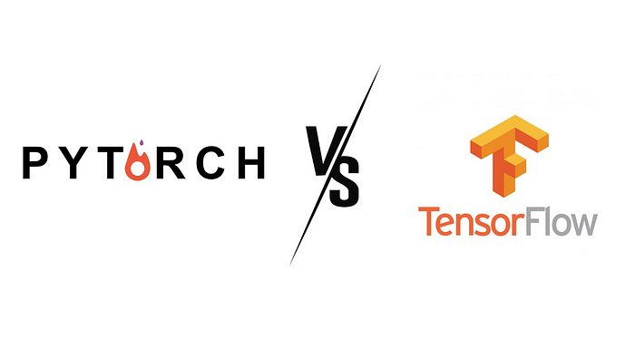

Deep learning frameworks are essential tools that simplify the development of artificial neural networks (ANNs), and their evolution has been rapid. Among these, TensorFlow and PyTorch stand out, each holding its own in various machine learning realms. But how does one decide the ideal tool for specific projects? This comprehensive guide aims to elucidate their strengths and weaknesses.

**Origins and Overview**

**TensorFlow**: Born from the brains at Google's Brain team, TensorFlow transitioned from being a proprietary tool to an open-source marvel. As an end-to-end platform, it offers everything from basic arithmetic operations to neural network deployment. Its adaptability is evident in its compatibility with platforms such as CPUs, GPUs, TPUs, and mobile devices. Notably, industry giants like Google, Uber, and Microsoft have integrated TensorFlow into their operations.

**PyTorch**: Introduced in 2016, PyTorch struck a chord by marrying user-friendliness with high performance. Its Pythonic design approach and dynamic computation graphs have made it a top choice in the research community. Developed primarily in C++, its efficiency is notable, and its adoption in platforms like Tesla Autopilot and Uber’s Pyro further attests to its capabilities.

**Spotlight on Advantages**

**TensorFlow's Strengths**:

* **Rich Ecosystem**: Its comprehensive array of libraries and tools positions TensorFlow as a holistic solution for machine learning tasks.
* **Versatility**: Its compatibility extends to various languages including C++, JavaScript, and Python.
* **TensorBoard**: An intuitive tool offering visualization that simplifies neural network examination and debugging.

**PyTorch's Strengths**:

* **User-centricity**: Its Python-centric nature ensures a seamless integration with Python code, making it highly appealing to data scientists.
* **Dynamic Computation Graphs**: PyTorch's support for dynamic computational graphs allows for real-time adjustments to models.
* **Effortless Multi-GPU Support**: With PyTorch, data parallelism and distribution of computational tasks are uncomplicated.

**Popularity Trends in Context: PyTorch vs TensorFlow**

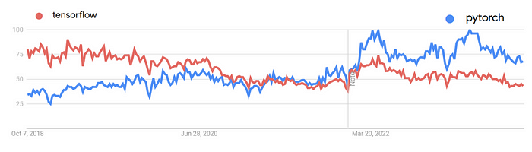

Google Trends: Tensorflow vs Pytorch — Last 5 years

The shifting dynamics in the popularity between PyTorch and TensorFlow over a period can be linked with significant events and milestones in the world of these frameworks:

* **TensorFlow’s Initial Popularity**: In the early phase of our timeline, TensorFlow had a distinct edge in popularity. This can be credited to its strong backing by Google and its wide-ranging tools that catered to both beginners and professionals.
* **PyTorch’s Rise**: Moving forward, PyTorch started gaining momentum. Its approach, which many found to be more flexible for research and experimentation, played a role in attracting attention. Additionally, as more resources and support became available for PyTorch, its user base grew.
* **Recent Landscape**: Towards the end, both PyTorch and TensorFlow have settled into their roles in the machine learning world. TensorFlow remains a solid pick for those looking at large-scale deployments and industry solutions. PyTorch, with its emphasis on flexibility, remains higher popularity for many specially in the research domain.

**Consider the Limitations**

**TensorFlow's Challenges**:

* **Complexity**: While versatility is a strength, it can introduce intricacies that may be daunting for some.
* **Rigidity**: Once a computational graph is set, making alterations is not straightforward.
* **Limited Initial GPU Language Support**: Earlier TensorFlow versions had GPU and language constraints.

**PyTorch's Challenges**:

* **Production Transition**: While PyTorch shines in research, transitioning to full production sometimes requires extra steps.
* **Visualization**: Out of the box, PyTorch doesn’t quite match TensorBoard’s visualization prowess.

**Deep Dive: Static vs. Dynamic Computational Graphs**

A foundational distinction between TensorFlow and PyTorch is their approach to computational graphs. TensorFlow employs static computational graphs, while PyTorch advocates for dynamic ones.

**TensorFlow: Embracing Eager Execution**

With the advent of TensorFlow 2.x, the framework transitioned from a static-graph paradigm to eager execution, which allows operations to be executed immediately as they are called. This shift makes TensorFlow more intuitive and user-friendly, aligning its usability more closely with PyTorch. However, TensorFlow still retains the ability to create static graphs via the tf.function decorator when optimization and performance are crucial.

Here’s how you can perform a simple sum operation in TensorFlow 2.x:

import tensorflow as tf  
  
# Input data  
a = tf.constant(1.0)  
b = tf.constant(2.0)  
  
# Execute the operation  
sum_ab = a + b  
print(sum_ab.numpy())

**PyTorch (Dynamic Computational Graph)**:

With PyTorch, operations are executed as they're written, and the graph is built dynamically.

import torch  
  
# Operations are performed immediately  
a = torch.tensor(1.0)  
b = torch.tensor(2.0)  
sum_ab = a + b  
  
print(sum_ab)

While TensorFlow's static approach can be optimized during graph compilation, it may be less intuitive, especially for those new to deep learning. Conversely, PyTorch's dynamic nature is more flexible and is especially beneficial for research.

**Deployment and Integration**

When considering deployment, especially in production environments, the framework’s compatibility with various platforms and ease of integration becomes crucial.

**TensorFlow**:

* **TensorFlow Serving**: Specifically designed for production-ready deployments. It supports multiple models and versioning, ensuring seamless transitions and rollbacks.
* **TensorFlow Lite**: Tailored for mobile and embedded devices, this allows machine learning on edge devices with resource constraints.
* **Cloud Integration**: Being a Google product, TensorFlow integrates efficiently with Google Cloud, offering advantages like scalable training and deployment.

**PyTorch**:

* **TorchServe**: A relatively new addition, TorchServe offers a straightforward way to deploy PyTorch models at scale. It handles tasks such as versioning and logging seamlessly.
* **ONNX Compatibility**: PyTorch models can be exported to ONNX (Open Neural Network Exchange) format, which ensures interoperability between deep learning frameworks and easier deployment on various platforms.
* **Native Mobile Support**: PyTorch offers native libraries to support both Android and iOS, streamlining the deployment process on mobile devices.

**Community Support and Documentation**

The growth, adaptability, and sustainability of a framework is often a reflection of its community’s vibrancy.

**TensorFlow**:

* **Vast Community**: TensorFlow has been around longer and has built a vast community. There’s a higher likelihood of finding solutions to common (and uncommon) problems on forums or Stack Overflow.
* **Comprehensive Documentation**: TensorFlow’s documentation is extensive, offering tutorials, guides, and best practices for a variety of tasks and levels.

**PyTorch**:

* **Rapidly Growing Community**: While newer, PyTorch’s community is rapidly growing, especially in academic and research circles.
* **User-Friendly Documentation**: PyTorch’s documentation is clear and concise, often praised for its simplicity and ease of understanding, especially for beginners.

**Future Trends and Development**

Keeping an eye on where each framework is headed can provide insights into their longevity and relevance.

**TensorFlow**:

* **Investment in TF 2.x**: With the release of TensorFlow 2.x, there has been a clear push towards making TensorFlow more user-friendly and intuitive, borrowing some of the best features from other frameworks.
* **Growing Ecosystem**: With tools like TensorFlow.js (for browser-based applications) and TensorFlow Hub (for reusable model components), the TensorFlow ecosystem continues to expand.

**PyTorch**:

* **Research to Production**: With tools like TorchScript and TorchServe, PyTorch is bridging the gap between research and production, ensuring that models can transition seamlessly.
* **Extended Libraries**: Libraries such as TorchText, TorchVision, and TorchAudio are being continually developed, offering pre-trained models and datasets for a range of applications, from NLP to computer vision.

**Making an Informed Choice**

Choosing between TensorFlow and PyTorch isn’t about selecting the “best” framework but about finding the one that aligns best with your needs. Both frameworks offer unique advantages and have made significant strides in addressing their initial limitations. By evaluating your project’s requirements, your familiarity with Python, the need for scalability, deployment preferences, and the kind of community support you’re seeking, you can make a choice that ensures efficiency and productivity. As the world of deep learning continues to evolve, so will these frameworks, and staying updated will empower you to make informed decisions time and again.